**2.1 – Quadratic Functions and Models**

**Objective: To identify important points of a quadratic function and model real life examples of their use**

**Quadratic Function:** a function of the form

$f\left(x\right)=ax^{2}+bx+c$ where $a≠0$

**Parabola:** the “U shaped” graph that is formed by a quadratic function

**Vertex Form:** another way of writing a quadratic equation,

where

Note: it is called vertex form because are able to easily identify the vertex

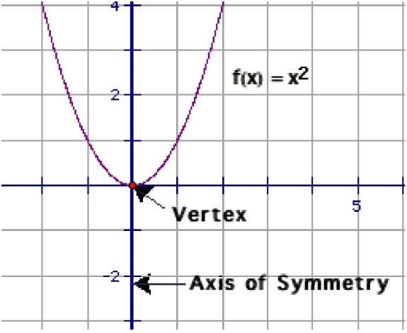**Vertex:** the highest (maximum) or lowest (minimum) point of a parabola where the axis of symmetry intersects our parabola (h, k)

**Axis of Symmetry:** The vertical line that divides are parabola into two mirror images of each other by passing through the vertex.  **Parent Graph $f\left(x\right)=x^{2}$**

**x-Intercept: where graph crosses x-axis (y=0)**

**y-Intercept: where graph crosses y-axis (x=0)**

**\*\*Remember the impact of a, h, and k.\*\***

-If a is positive our “U” opens up

-If a is negative our “U” opens down

-If a > 0 there is a stretch (narrow)

-If 0 < a < 1 there is a compression (wide)

-h moves the graph left and right (the x-value of the vertex)

-k moves the graph up and down (the y-value of the vertex)

Parabolas are a very common shape in the real world.

What are some things that are in the shape of a parabola?

**-**Bridges, roller coasters, satellites, McDonalds, arch (kind of), three-point line, fountain, rainbow, flashlight, angry birds, the path of an object when thrown…

What do these have in common?

When would we have a “highest point” when would we have a “lowest point”? What do these points represent?

*Examples:*

Imagine you are throwing rocks one day after school. Your awesome math teacher walks by and watches you for a moment before telling you that it appears that the path of the rocks when you throw them are modeled by the equation : $d={-t}^{2}+6t$

Where d is the distance from the ground (the height) and t is the time in seconds that the rock is in the air. This obviously interests you and you now want to know how high are you actually throwing the rocks and after how many seconds does it reach this point? You are then curious how long the rock is in the air all together. What do you find out?

Example:

You are at a fair and in order to win a prize you need to toss a ball into the tiny basket. After throwing the ball you notice that the path it is traveling on is modeled by the equation $h={-t}^{2}+4t$**+1** where h is the height of the ball and t is the time in seconds. You know that the center of the basket is located at the point (3, 2). Do you make the shot? What if it was at (4,1)?

**Homework**

**Pg 132 #7-12, 21-27 (odd), 49, 76**

**Additional (unnecessary because of graphing calc) Info**

**Standard Form:** a function of the form

$f\left(x\right)=ax^{2}+bx+c$ where $a≠0$

**Parabola:** the “U shaped” graph that is formed by a quadratic function

**Vertex Form:** another way of writing a quadratic equation,

where

Note: it is called vertex form because are able to easily identify the vertex

**Vertex:** the highest (maximum) or lowest (minimum) point of a parabola where the axis of symmetry intersects our parabola (h, k)

**Axis of Symmetry:** The vertical line that divides are parabola into two mirror images of each other by passing through the vertex.

**Parent Graph $f\left(x\right)=x^{2}$**

**Standard Form;**

|  |  |  |
| --- | --- | --- |
| **Form** | **Equation** | **Characteristics** |
| *Standard* | y = ax2 + bx + c | x-coordinate of vertex is |
| axis of symmetry is |

*Examples:*

*Write the equation in Standard Form:*

1. y = (x + 1)(x + 2)

$y=x^{2}+3x+2$

1. y = - 2(x + 4)(x – 3)

1. y = 4(x + 1)2 + 5

Steps to Graphing Quadratic Equation in Standard Form:

**Identify a, b and c.**

**1) Find and Plot Vertex**

* , Substitute in x and solve for y

**2) Draw Axis of Symmetry**

* Vertical line at 

**3) Find and Plot two points on one side of axis of symmetry**

* Choose x values and solve for y values

**4) Use symmetry to plot symmetric points on opposite side of axis of symmetry**

**5) Draw a parabola through the plotted points**